HACKATHON 2.0
Product Requirements Document (PRD)
Analytix — Minutes Operational Assistant

1. Document Information & Product Summary
Product Name | Analytix — Minutes Operational Assistant
Solution Type | Software - Web Application
Prepared By | Analytix Track Team
Document Version | 2.1 (Baseline Hackathon PRD)
Date | September 2026

Product Summary: Analytix is an operational web assistant designed to streamline meeting capture, minutes generation, and knowledge retrieval. The application allows users to share browser audio streams (such as PPTLinks tabs), streams real-time transcription via the Deepgram Streaming API, automatically extracts structured and editable meeting minutes, and offers a grounded conversational RAG chatbot for past meeting queries. A future upscale module aggregates multi-meeting weekly reports.
2. Problem Statement
Organizations lose operational momentum due to manual meeting note-taking, fragmented action item tracking, and unsearchable meeting recordings. Key decisions and assigned deadlines are frequently buried in long recordings or informal notes, leading to delayed execution and lack of accountability.
Problem Evidence / Assumptions to Validate
- Live Audio Stream Need: Teams require a continuous live stream of transcripts during virtual presentations to avoid missing critical verbal context.
- Human Review Requirement: Post-meeting editing is essential because raw STT outputs require human review for accuracy before official distribution.
- Knowledge Search Demand: Project leads need a direct natural language interface to query past meeting knowledge with verifiable source citations.
3. Product Goal & Objectives
Product Goal: To establish an automated operational pipeline that captures live meeting audio, produces verified structured minutes, enables grounded cross-meeting retrieval, and scales into executive multi-meeting reporting.
ID | Objective | How Completion Will Be Gauged
01 | Objective 01 — Browser Audio Capture and Live Transcription  The user shares a PPTLinks tab audio stream, and the transcript updates continuously in Analytix. | User initiates getDisplayMedia() tab capture; live transcript updates continuously in UI via Deepgram Streaming API with <1.5s latency.
02 | Objective 02 — Structured Minutes Extraction  The approved transcript produces editable meeting details, including the title, agenda, decisions, action tasks, assigned owners, and deadlines. | LLM extraction pipeline yields structured, editable fields (title, agenda, decisions, tasks, owners, deadlines) in UI dashboard.
03 | Objective 03 — Conversational RAG Chatbot  Users ask questions about indexed meetings and receive grounded answers with source references where available. | RAG engine responds to user queries with verified answers and precise document/meeting source citations.
04 | Objective 04 — Weekly Summaries Report — (Future Upscale)  Multiple saved meetings can be aggregated into an executive report. Friday automation and email delivery remain future or stretch functionality. | Multi-meeting aggregator synthesizes saved sessions into executive digests. Friday email scheduling tested as stretch functionality.
4. Target Users & Personas
User | Need | Typical Action | Success Condition
Executive Secretary / Admin | Capture PPTLinks tab audio and generate editable minutes | Initiate browser capture stream, review & edit extracted details | Real-time transcript & structured editable minutes
Project Lead / Manager | Instant knowledge search & action item verification | Query RAG Chatbot on past decisions & assigned owners | Grounded answers with source references
Executive Leadership | Cross-meeting operational synthesis | Review aggregated multi-meeting summary reports | Structured executive digests (Future Upscale)

Primary Persona Example: Amina, 29, is a Technical Program Manager overseeing weekly cross-functional PPTLinks presentation meetings. She needs a tool that streams live transcripts as presentations occur, automatically formats structured action items with assigned owners and deadlines for editing, and lets her query past meeting decisions during strategy planning.
5. Value Proposition & Significance
5. WEB DEPLOYMENT & PRODUCTION INFRASTRUCTURE (GO-LIVE SPECIFICATION)

To enable live public access for users and hackathon evaluators, Analytix is deployed to cloud hosting infrastructure via automated CI/CD pipelines:

5.1 Frontend Web Hosting (Vercel / Netlify)
• Application deployed as a live web application connected to the primary GitHub repository.
• Automatic SSL certificate provisioning (HTTPS enforced, which is strictly required by browser security policies for getDisplayMedia audio capture).
• Environment variable binding for backend API gateway endpoints.

5.2 Backend API Gateway (Render / Railway / AWS EC2)
• FastAPI Python backend packaged via Docker containers running Uvicorn/Gunicorn async workers.
• Persistent WebSocket server configured to stream real-time PCM audio chunks directly to Deepgram Streaming API.

5.3 Vector Storage & Database Persistence (ChromaDB Cloud / Managed PostgreSQL)
• Vector database hosted on ChromaDB cloud instance to store and retrieve embedded meeting transcripts for RAG chatbot queries.
• Relational database to persist structured JSON records (title, agenda, decisions, tasks, owners, deadlines).

5.4 Continuous Integration & Continuous Deployment (CI/CD)
• Automated GitHub Actions workflow triggering build, test, and deployment jobs upon main branch updates.
• Zero-downtime deployment setup ensuring continuous availability during testing.
6. Proposed Solution & User Experience
The MVP is a responsive web application. Users initiate tab capture via getDisplayMedia(), stream audio live to Deepgram, validate extracted structured details, and query past sessions via the RAG interface.
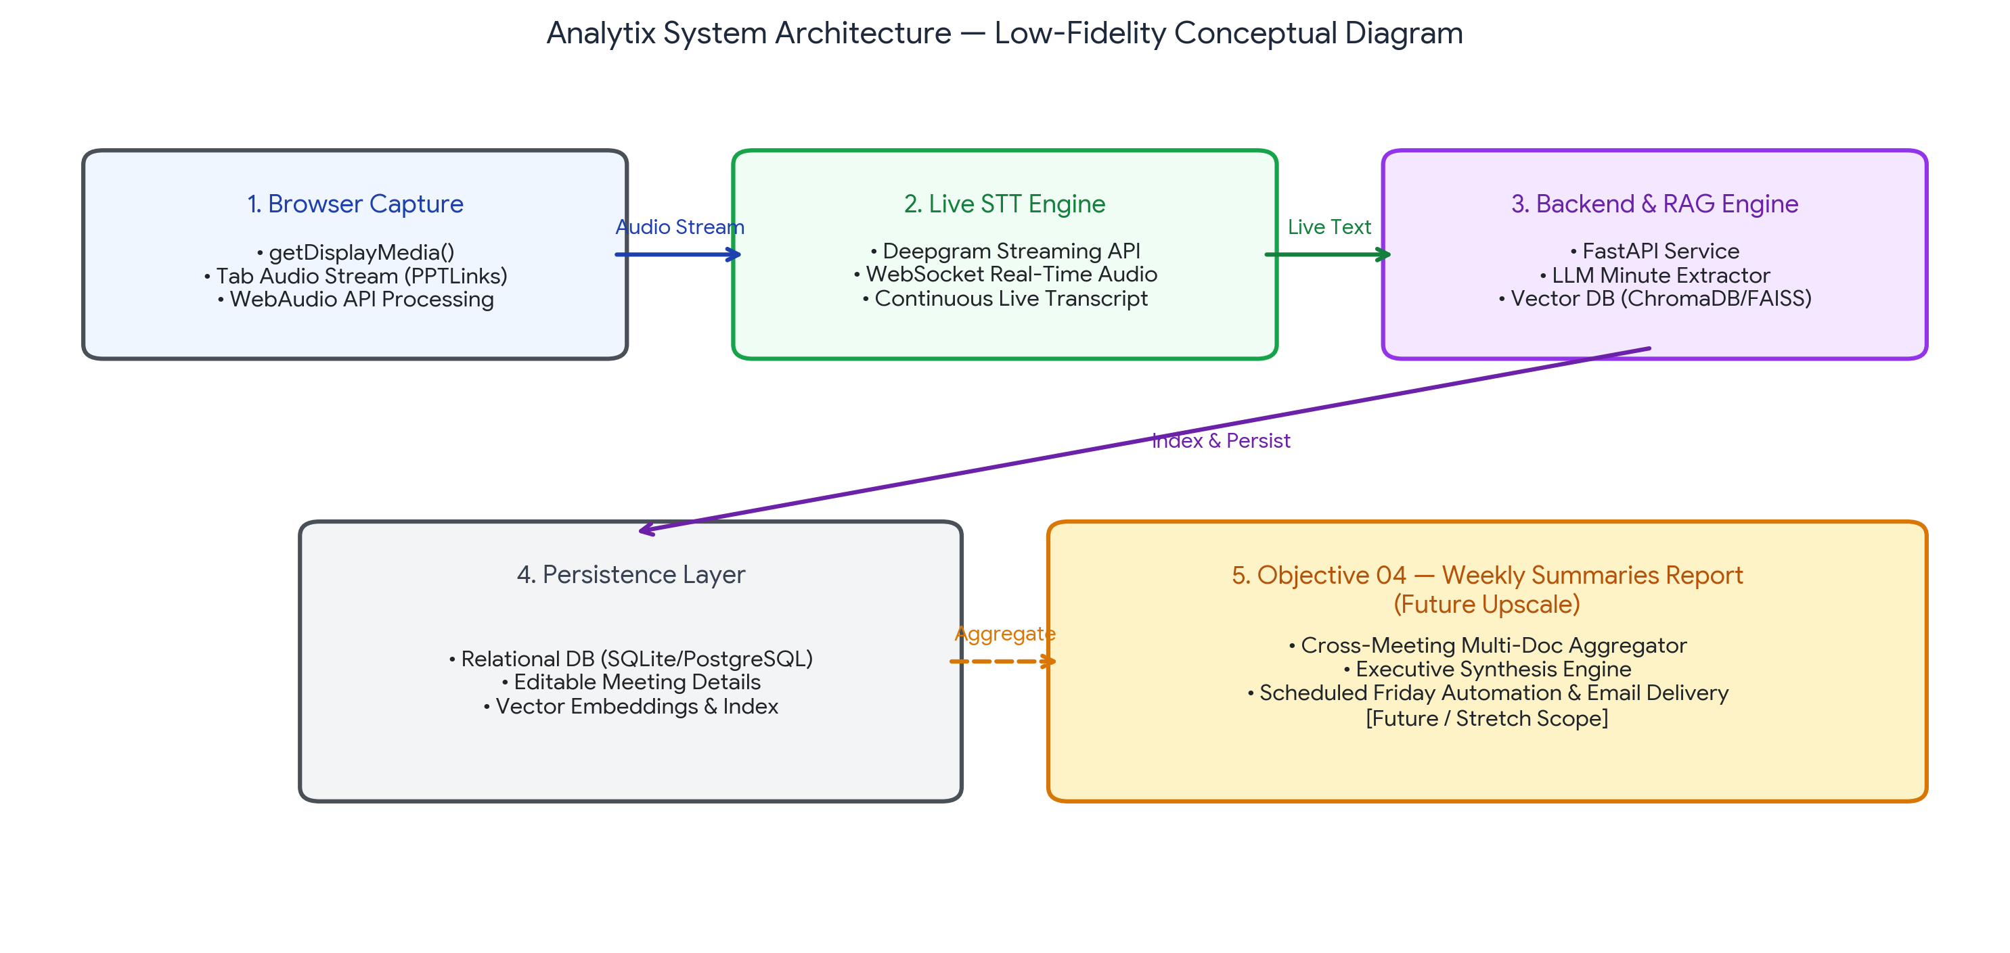
Figure 1. Analytix System Architecture Diagram showing Browser Audio Capture, Deepgram STT, RAG Engine, and Objective 04 Future Upscale.
6.1 Low-Fidelity User Interface Wireframes
Below are the low-fidelity wireframe blueprints representing the 6 primary user interface screens of the Analytix Web Application platform, capturing the entire end-to-end operational workflow:
Dashboard View
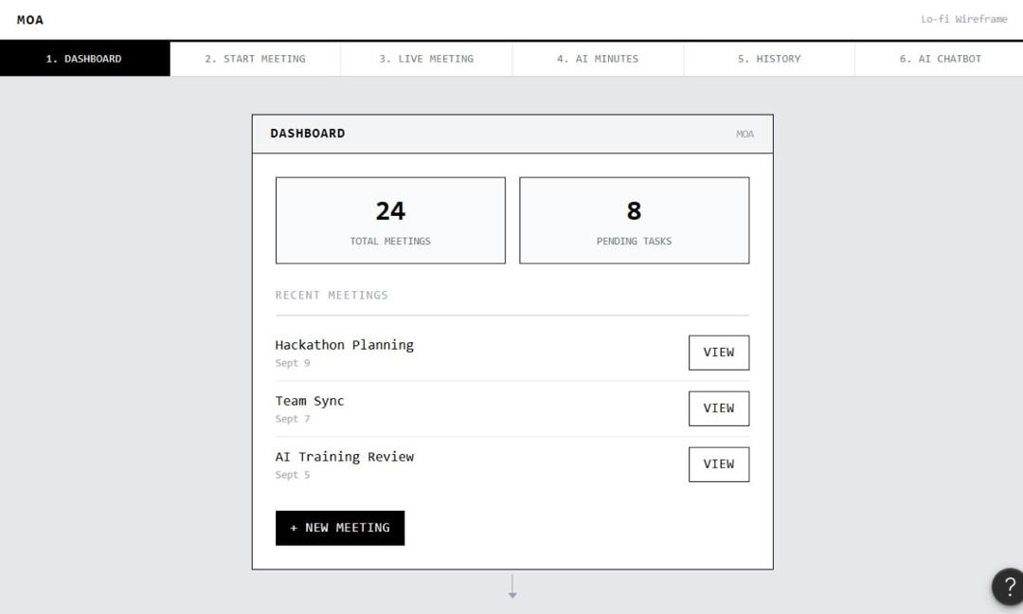
Figure 2. Module 1: Dashboard UI Wireframe — Metrics, Recent Meetings, and Action Triggers.
Start Meeting View
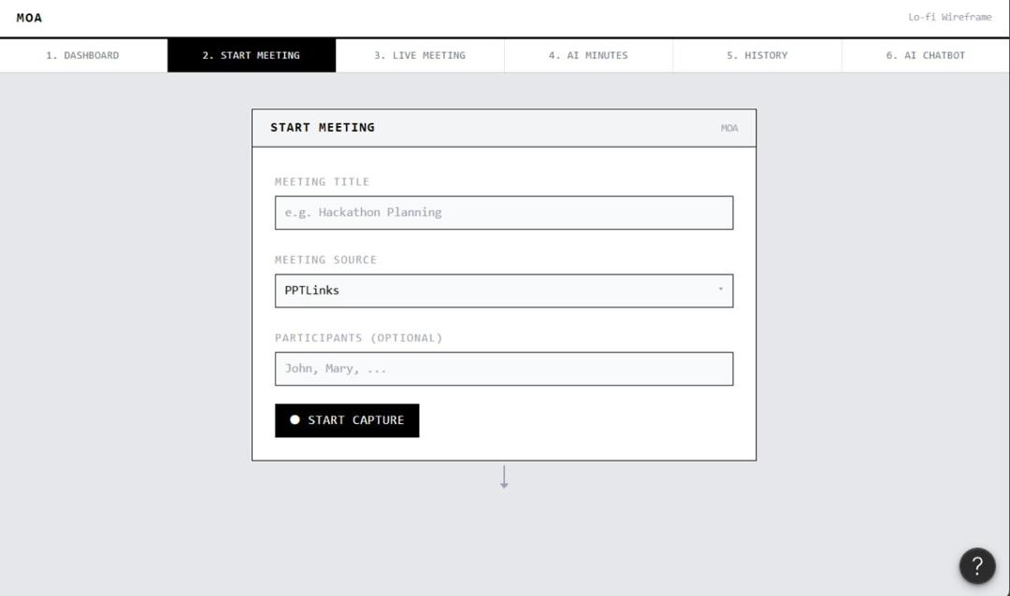
Figure 3. Module 2: Start Meeting UI Wireframe — Session Configuration and Source Selection.
Live Meeting View
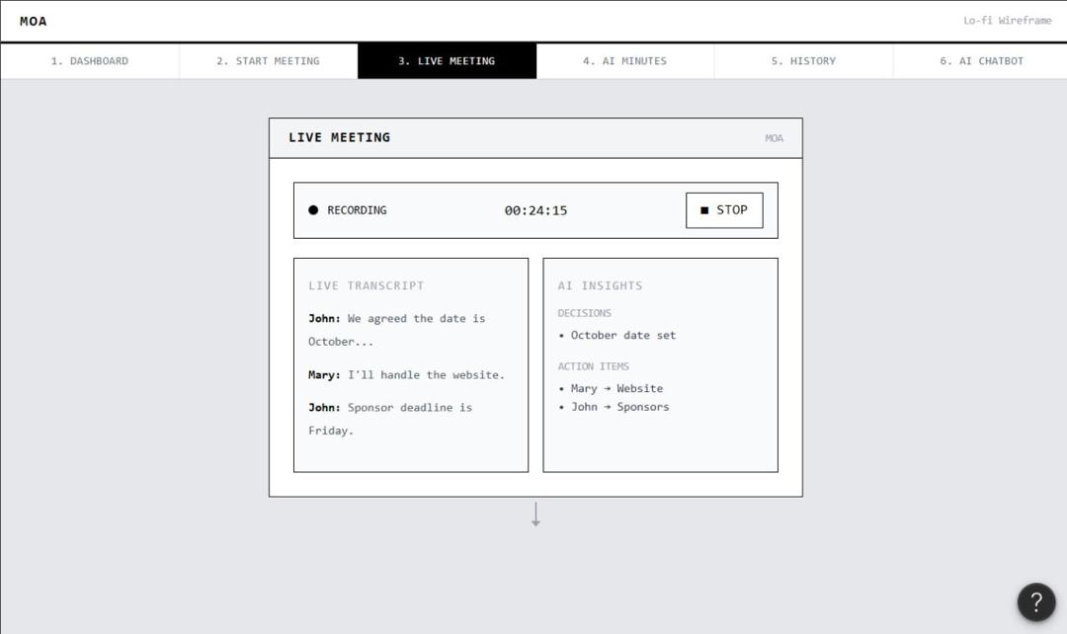
Figure 4. Module 3: Live Meeting UI Wireframe — Real-Time Streaming Audio Transcription & Insights
AI Minutes Review
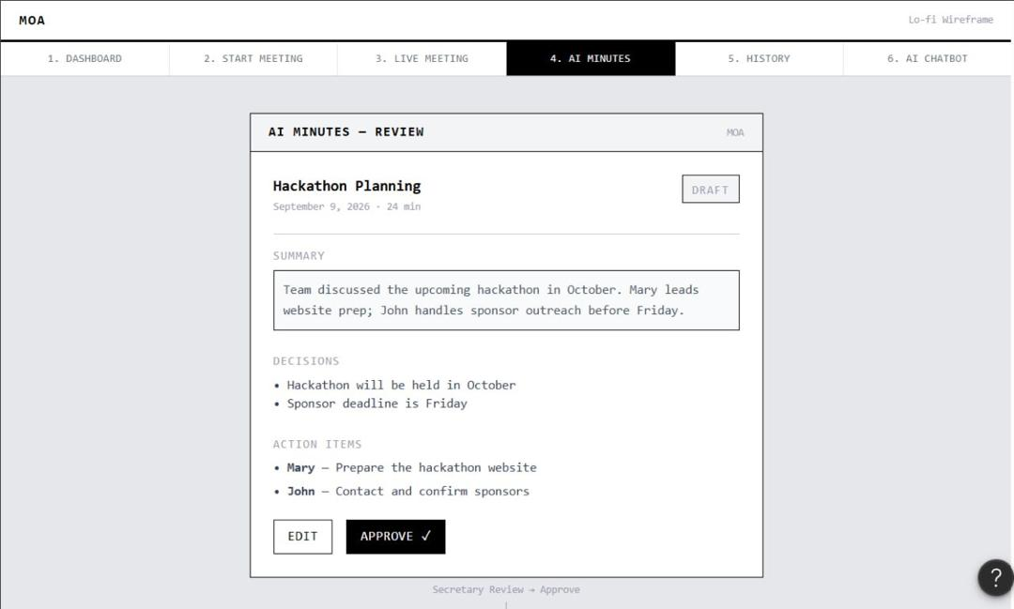

Figure 5. Module 4: AI Minutes Review UI Wireframe — Structured Minutes Review and Verification.
Meeting History View
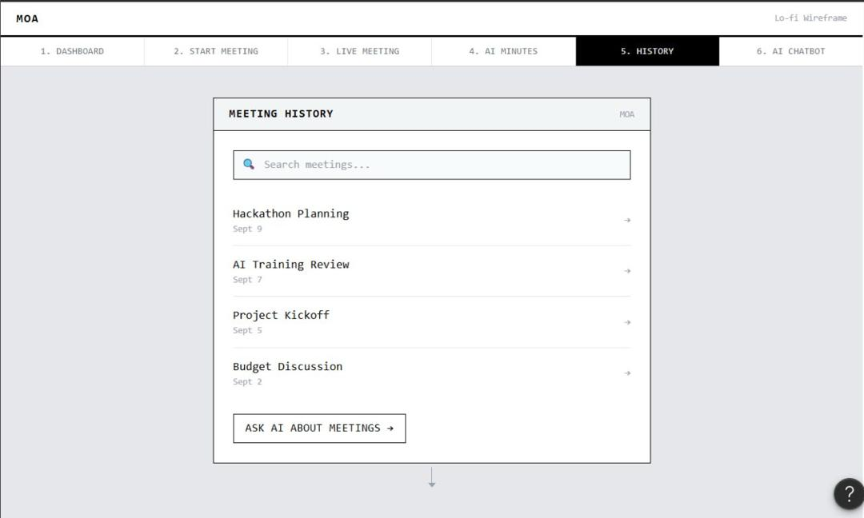
Figure 6. Module 5: Meeting History UI Wireframe — Searchable Historical Meeting Archive.
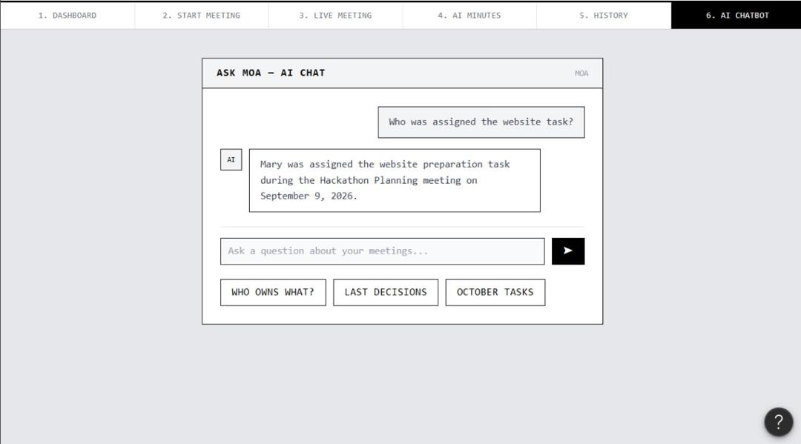
Figure 7. Module 6: AI Chatbot UI Wireframe — Conversational RAG Query Interface.
7. Functional Requirements
ID | Requirement Description | Priority | Acceptance Summary
FR-01 | Browser Tab Audio Capture  Capture PPTLinks audio via getDisplayMedia() flow. | Must | Audio stream captured natively from selected browser tab.
FR-02 | Live Streaming Transcription  Stream audio to Deepgram API for live transcript. | Must | Transcript streams continuously into UI with minimal delay.
FR-03 | Structured Minutes Extraction  Extract title, agenda, decisions, action tasks, owners, deadlines. | Must | Produces editable fields for user review and approval.
FR-04 | Conversational RAG Chatbot  Query indexed past meeting transcripts. | Must | Grounded responses returned with valid source references.
FR-05 | Weekly Summaries Report (Future Upscale)  Aggregate saved meetings into executive reports. | Future / Stretch | Multi-meeting synthesis engine and Friday email automation.
8. Non-Functional Requirements
Area | Requirement / Metric | Verification Method
Performance | Deepgram live transcript updates continuously in UI with <1.5s delay. | Real-time stream timing test
Reliability | 100% structured JSON format adherence for editable fields. | Schema validation unit tests
Accuracy | Conversational Q&A returns accurate answers with valid source references. | Grounding evaluation suite
Scalability | Multi-meeting aggregation executes within 20s when triggered. | Batch processing test
9. MVP Scope & Prioritization
Priority | Included Features | Hackathon Decision
Must Have | Browser audio capture (getDisplayMedia), Deepgram Streaming API live transcription, LLM minute extraction (Title, Agendas, Decisions, Action Tasks, Owners, Deadlines), ChromaDB Vector RAG Chatbot with source citations. | Build and test for MVP Baseline
Future / Stretch (Objective 04) | Weekly Summaries Report aggregating multiple saved meetings into executive digests, Friday cron automation, and automated email delivery. | Future / Stretch Scope
Out of Scope | Speaker diarization via biometric voiceprints, live language translation, native desktop/mobile applications. | Deferred post-hackathon
10. System Architecture & Technical Design
Layer | Technology Selected | Rationale & Technical Fit
Audio Capture Flow | getDisplayMedia() / WebAudio API | Browser-native screen/tab audio capture for streaming PPTLinks audio.
Live Speech-to-Text (STT) | Deepgram Streaming API | Real-time WebSocket streaming transcription replacing Whisper API.
Backend API Gateway | FastAPI (Python Async) | High-concurrency streaming and orchestration service.
Structuring Engine | LLM JSON Extractor (Ollama/Groq) | Extracts editable meeting details (Title, Agendas, Decisions, Tasks, Owners, Deadlines).
RAG & Vector Search | ChromaDB / FAISS + MiniLM | Indexes approved transcripts for grounded conversational Q&A with source references.
Weekly Summaries (Upscale) | APScheduler + Email Service | Future/stretch module for multi-meeting aggregation and Friday email dispatches.
11. Acceptance Criteria & Success Metrics
Objective / Area | MVP Acceptance Criterion | Pass Condition
Objective 01 — STT | Shares PPTLinks tab audio; transcript updates continuously in UI. | Continuous text flow with <1.5s streaming latency.
Objective 02 — Minutes | Produces editable title, agenda, decisions, action tasks, assigned owners, deadlines. | Full schema JSON population in UI editor.
Objective 03 — RAG | Answers queries on indexed meetings with grounded source references. | Grounded answers returned with valid source metadata.
Objective 04 — Upscale | Aggregates multiple saved meetings into executive report. | Cross-meeting synthesis completes successfully.
12. Risks, Constraints & Assumptions
Risk / Constraint | Impact | Likelihood | Mitigation
Browser Audio Permission Denial | High | Medium | Provide clear step-by-step UI prompt for getDisplayMedia() tab audio sharing.
Deepgram WebSocket Drop | High | Low | Implement auto-reconnect logic and chunk buffer in client script.
LLM Schema Hallucination | Medium | Medium | Enforce JSON mode validation and fallback field defaults.
13. Development Plan & Milestones
Phase | Primary Focus & Deliverables | Target Milestone
Phase 1 — Capture & STT | Implement getDisplayMedia() tab audio capture & Deepgram streaming connection. | Objective 01 Baseline Completed
Phase 2 — Minutes & RAG | Build editable meeting details UI, minute extractor, and ChromaDB RAG chatbot. | Objective 02 & 03 Completed
Phase 3 — Future Upscale (Stretch) | Develop cross-meeting report aggregator UI and Friday automated email dispatch. | Objective 04 Future Upscale Ready
Phase 4 — Testing & Pitch | End-to-end integration testing, low-fi architecture validation, and pitch prep. | Final Hackathon Submission

